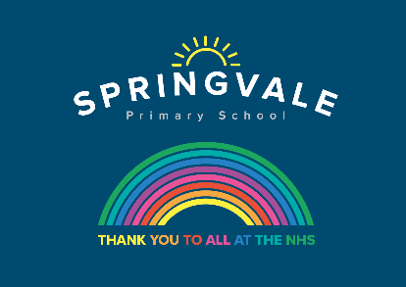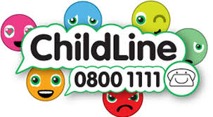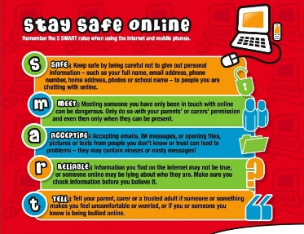

|  |  |
| --- | --- |
| **W/C 13.7.20: Learning Project - Space** | |
| **Age Range:** Nursery | |
| **Weekly Reading Tasks** | **Weekly Phonics Tasks** |
| **Monday-** Visit [Storytime from Space](https://storytimefromspace.com/a-moon-of-my-own-2/) and let your child listen to the Story Time video of A Moon of My Own. | **Monday-** Play the online game ‘[Picnic on Pluto’](https://www.phonicsplay.co.uk/PicnicOnPluto.html). If your child is not at the stage of reading independently, you could sound the words out for them to blend together. |
| **Tuesday-** Listen to a space themed online story, [Aliens Love Underpants](https://safeyoutube.net/w/ZYg6), [Roaring Rockets](https://safeyoutube.net/w/mZg6) and [Whatever Next?](https://safeyoutube.net/w/tZg6) Which is your favourite? Why? | **Tuesday-** Play ‘I Spy in Space’. ‘*I spy, with my little eye, something beginning with t*’. |
| **Wednesday-** Using the space stories as a starting point, ask your child to make up their own story about space. It could use the same characters or settings as one of the stories you have shared together. | **Wednesday-** Write different sounds on paper (maybe re-use the sounds from a previous project). Put the sounds together to make different words only changing the initial sound e.g. t-i-n (tin), b-i-n (bin), ch-i-n (chin). |
| **Thursday-** Ask your child to draw a picture of one of the events from their made up space story. Can they explain what’s happening in the picture? Or, for more of a challenge, can they draw a book cover for their space story? | **Thursday-** Your child can list things they would see in space that begin with the letters S, P, A,C & E. Then your child can practice writing these letters in space (in the air) using their finger or a pencil. |
| **Friday-** Visit Oxford Owl [ebooks](https://www.oxfordowl.co.uk/oxford-owl-ebook-collection). Look at the picture book: ‘In the Sky’. Talk about the story together. What is happening on each page? | **Friday-** Play, [‘Pick a Picture’.](https://www.phonicsplay.co.uk/PictureMatch.html) You can orally sound out the word for your child for them to blend together if they are not yet at the stage of reading independently. |
| **Weekly Writing Tasks** | **Weekly Maths Tasks- Length and Height** |
| **Monday-** Ask your child to draw their own alien and label it. | **Monday-** Ask your child to make different rockets out of playdough or strips of paper. Can they make a long rocket? A short rocket? A thick rocket? |
| **Tuesday-** Write an [invitation](http://lovemybooks.co.uk/wp-content/uploads/2014/07/Qpootle-5-invitation.pdf) to the alien to invite them to your very own space party. | **Tuesday-** Your child can compare objects from around the house or outside. Ask them if the object is longer, the same length or shorter? Order the objects. |
| **Wednesday-** Your child can draw out or write their own menu for an alien. What does an alien eat? Moon-burgers, star biscuits or fruit rockets. Click [here](https://www.pinterest.co.uk/lars0508/space-party-foods/) for more ideas. | **Wednesday-** Work with your child to design a rocket using different 2D shapes. This could be done with 3D shapes if you have spare boxes and resources at home. |
| **Thursday- Task your child with designing their own spaceship. Can they describe how the machine would move and label it using verbs?** | **Thursday-** Ask your child to use Lego, blocks or cardboard boxes to build a tower that is the same height as them, taller than them and shorter than them. |
| **Friday-** Ask your child to look up to the sky and down to the ground. Ask them to draw what they can see and have a go at completing the sentence, I can see a.. | **Friday-** Play the online game [Let’s Compare](https://www.topmarks.co.uk/early-years/lets-compare). Following this, your child can sing the song [Short or Tall](https://safeyoutube.net/w/Aah6)**.** |

|  |
| --- |
| **Learning Project - to be done throughout the week** |
| **The project this week aims to provide opportunities for your child to learn more about space. Learning may focus on our Solar System, the Sun and the Moon. It could look at life in outer space from the view of an astronaut and travelling through space.**    **Remarkable Rockets**   * Use junk modelling or craft items you have around your house to create your own rocket. Toilet roll tubes are a good starting point. You could have rocket races in the garden:   + Tie a string up at an angle or use the washing line.   + Blow up a balloon and sellotape it to your rocket. Hold the end of the balloon but do not tie it.   + Let the balloon go and watch your rocket fly!   **Make a Textured Planet**   * Work with your child to create a replica of a planet. You could papier mache a balloon, or colour, paint or stick bits of materials on to the card to create textured effects. This shaving foam paint technique (see picture) creates a great textured finish when dry. Simply spray shaving foam onto a plate and drop in food colouring or poster paint.   **Explore Space Online**   * Support your child in looking at the Earth from space using the [Google Earth](https://earth.google.com/web/@13.66454264,-49.21573769,-9866.46203551a,37211930.69500923d,35y,0h,0t,0r) programme and identifying simple features such as water. * Can you find your home? What does your child notice about the surrounding area?   **Phone Home**   * **Create a space phone with your child using items from around the home. Get them to practise forming numerals correctly to create the buttons.** * **Make a space phone book to support roleplay. Ask your child to draw a picture of a different alien on each page and write a phone number for them.**   **Have a Space Themed Party/Picnic**   * Support your child to use tin foil to create shiny space suits for their teddies and dolls. They could have a space-themed teddy bear’s picnic afterwards where they share the biscuits in the next activity! * Make yummy star biscuits to share at the picnic. Click [here](http://saucepankids.com/recipe/simple-shortbread-biscuits/) to find instructions on how to support your child in making simple star biscuits. They could share them at their space themed teddy bear’s picnic. |